**Panel Econometrics**

Assignment #5

By Chuxin Liu

**Question 1: Print out descriptive statistics (mean and standard deviation) of the raw variables and the created variables.**

Table 1: Summary Statistics

|  |  |  |
| --- | --- | --- |
|  | (1) |  |
|  | mean | sd |
| price | 68.69993 | 41.98626 |
| pop | 4537.113 | 4828.836 |
| pop16 | 3366.616 | 3641.847 |
| cpi | 73.59667 | 36.52933 |
| ndi | 7525.023 | 4747.859 |
| sales | 123.9509 | 30.99105 |
| pimin | 62.89928 | 38.32313 |
| lnc | 5.23227 | .6054225 |
| lnclag | 5.266399 | .5854589 |
| lnp | 4.498752 | .1517772 |
| lny | 9.150421 | .2099475 |
| lnpn | 4.410703 | .1511349 |
| *N* | 1380 |  |

Created variables: lnc lnclag lnp lny lnpn

**Question 2: Replicate the results of Table 8.1**

Table 2.1: Replication of Table 8.1 (1)

|  |  |  |  |  |  |
| --- | --- | --- | --- | --- | --- |
|  | (1) | (2) | (3) | (4) | (5) |
|  | OLS | Within | TSLS | TSLSKR | Within2SLS |
| lnclag | 1.013*** | 0.830*** | 1.047*** | 1.014*** | 0.568*** |
|  | (0.00252) | (0.0126) | (0.00719) | (0.00307) | (0.0357) |
| lnp | 0.00410 | -0.292*** | 0.0252 | -0.267*** | -0.517*** |
|  | (0.0144) | (0.0231) | (0.0159) | (0.0289) | (0.0388) |
| lny | -0.0616*** | 0.107*** | -0.0219* | -0.0951*** | 0.228*** |
|  | (0.00710) | (0.0233) | (0.0109) | (0.0143) | (0.0309) |
| lnpn | 0.0791*** | 0.0355 | 0.0942*** | 0.387*** | -0.0141 |
|  | (0.0141) | (0.0266) | (0.0153) | (0.0286) | (0.0314) |

Table 2.2: Replication of Table 8.1 (2)

|  |  |  |  |  |
| --- | --- | --- | --- | --- |
|  | (1) | (2) | (3) | (4) |
|  | FD2SLS | FD2SLSKR | GMM1Step | GMM2Step |
| lnclag |  |  | 0.833*** | 0.724*** |
|  |  |  | (0.0285) | (0.147) |
| lnp |  |  | -0.370*** | -0.405*** |
|  |  |  | (0.0427) | (0.0437) |
| lny |  |  | 0.134* | 0.271 |
|  |  |  | (0.0612) | (0.260) |
| lnpn |  |  | -0.0278 | -0.0492 |
|  |  |  | (0.0585) | (0.0500) |
| D.lnclag | 0.241*** |  |  |  |
|  | (0.0614) |  |  |  |
| LD.lnc |  | 0.252*** |  |  |
|  |  | (0.0201) |  |  |
| D.lnp | -0.391*** | -0.227*** |  |  |
|  | (0.0272) | (0.0421) |  |  |
| D.lny | 0.199*** | 0.698*** |  |  |
|  | (0.0440) | (0.0410) |  |  |
| D.lnpn | -0.00434 | 0.186*** |  |  |
|  | (0.0353) | (0.0417) |  |  |

**Question 3: How many instruments does each of the two HT regressions use, and thus what are the degrees of freedom of the test for overidentification?**

Exogenous time-varying variables:

Endogenous time-varying variables:

Exogenous time-invariant variables:

Endogenous time-invariant variables:

HT uses instruments:

# of instruments: 4+5+4+2=15

# of degree of freedom of the test for overidentification: 4-1=3

AM uses instruments: where

# of instruments: 4+5+4*7+2=39

# of degree of freedom of the test for overidentification: 4*7-1=27

**Question 4: Compare the RE (or GLS), FE (or WE), and AM estimators: do the proper HT and Hausman tests to figure out your recommended estimator.**

1. FE vs. AM with df=27 (insignificant)

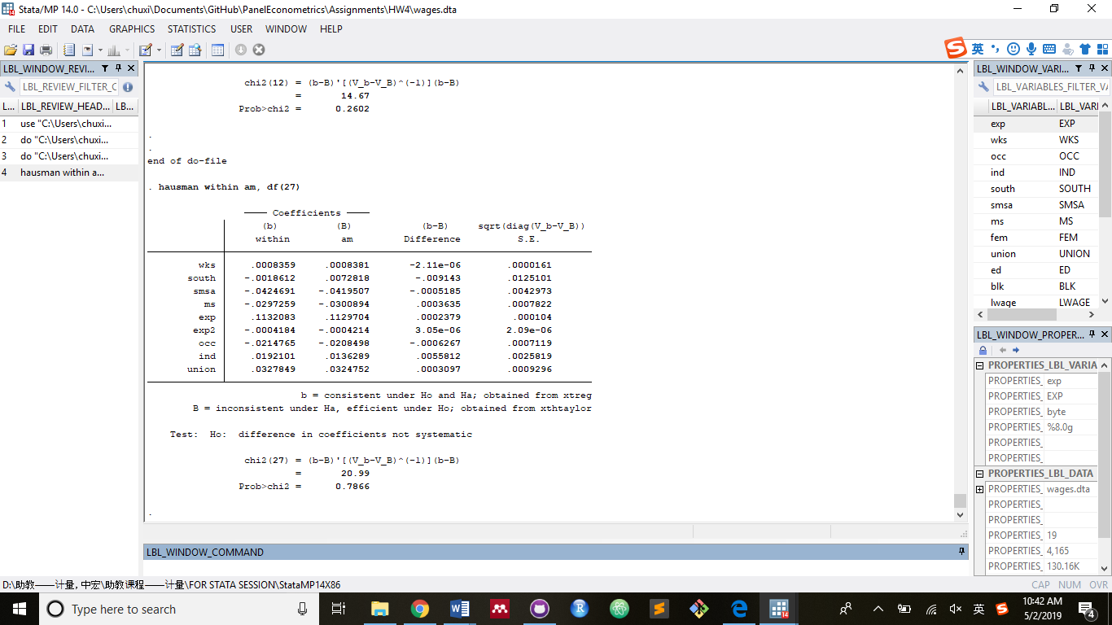

Insignificant test result suggests that AM or GLS will be more efficient than FE.

1. RE vs. AM (significant)

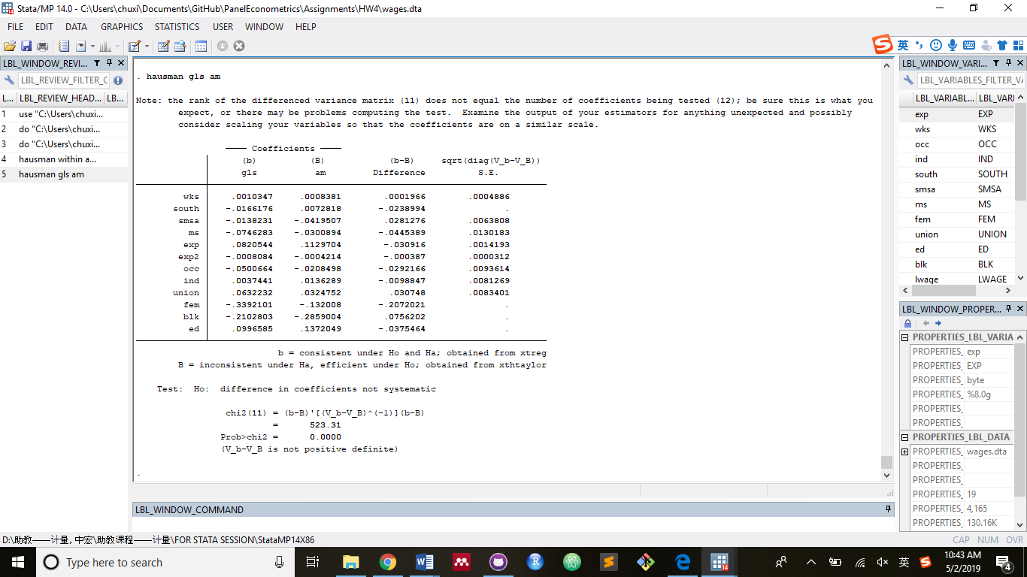

Significant result suggests that AM is more consistent than GLS.

**Appendix: STATA Codes**

